JPPS Student Wellbeing Program
Parent Information Sheet

JPPS have introduced a Wellbeing Officer role in 2022 to complement our existing Wellbeing programs. The Wellbeing Officer coordinates the Kids Hope Mentoring program, oversees small group Wellbeing programs, provides short/medium term individual counselling support to students, and works with JPPS staff and families on ways to support students achieve their best outcomes at school.
JPPS Students and Parents who would like to request support through the JPPS Wellbeing Program are encouraged to contact JPPS Staff (Classroom Teacher, Leadership, etc) to discuss suitability for a Wellbeing referral.

Pathways for Wellbeing support:
I am concerned about something happening in my child’s life that is URGENT in nature
For example, family medical crisis, mental health crisis, grief and bereavement, critical incident, family violence, etc.
Pathways to support
- Discuss with JPPS Leadership. These matters will generally be referred to Department of Education and Training (DET) support programs
- Speak to classroom teacher about ways to support your child with these concerns at school
- Appointment with GP or other health professional or referral to crisis intervention service

I am concerned about something that is ongoing in nature that is impacting my child’s wellbeing, both outside school and at school
For example, separation anxiety, significant mental health challenges, traumatic impact of abuse or neglect, familial separation or breakdown, family relationships/attachment issues, learning engagement, academic progress, etc.
Pathways to support:
- Discuss with JPPS Leadership. These matters may be referred to available DET programs
- Mental Health Care Plan Psychological Support (through GP referral)
- Speak to classroom teacher about ways to support your child with these concerns at school
- Request phone call with JPPS Wellbeing Officer for support with exploring external referral services eg. Family support service
- JPPS Wellbeing Referral in consultation with your child’s classroom teacher

I am concerned about something that that is impacting my child’s wellbeing at school and their ability to engage with their learning e.g. anxiety regarding learning, school refusal, peer connectedness, etc.
Pathways:
- Contact your child’s classroom teacher to discuss your concerns via email or request a meeting time
- Discuss with classroom teacher ways to support your child with these concerns at school ie. In the classroom, outside, before/after school
- Discuss whether a referral for JPPS Wellbeing support is appropriate at that time and provide the classroom teacher with information needed to support the JPPS Wellbeing referral process
- JPPS Student Wellbeing Officer is onsite three days a week. Wellbeing referrals may not be allocated immediately depending on the case load of the Wellbeing Officer at the time of referral
- Referrals will be allocated based on capacity and urgency, with students at risk of educational disengagement receiving highest priority
- Teachers will receive an email from the JPPS Wellbeing Officer acknowledging receipt of the referral once it is submitted
- When the referral is allocated, the JPPS Wellbeing Officer will make contact via phone/email to arrange a meeting time with parents, and with the referring school staff member
- A plan for student support will be discussed once these meetings have occurred
- If circumstances change before the referral is allocated and particularly if there is an escalation in concerns, please keep JPPS school staff informed

Wellbeing Support at JPPS can look like:
- Short/medium term individual counselling
- Teacher support
- Consultation with families
- Peer support
- Small group programs eg. Social skill development
- Cohort/Year Level Wellbeing programs
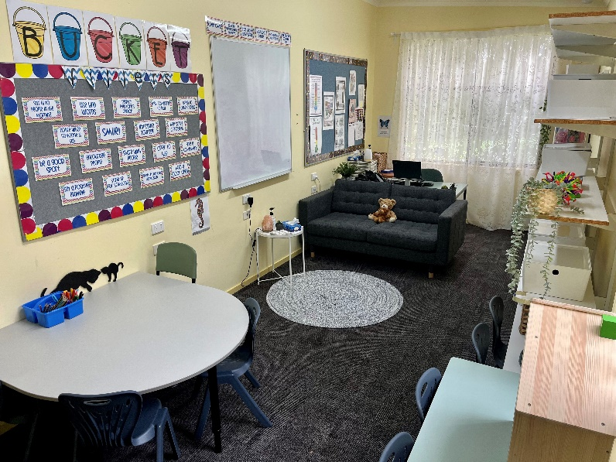

Laura Serong
JPPS Student Wellbeing Officer

